BRIDGE TE AROHA: lovely place, lovely game ♠♥♦♣
Te Aroha News March 2026
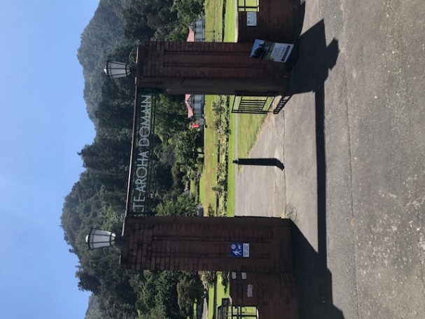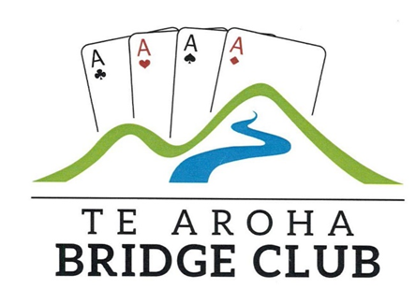
A Day at the Domain: Sunday March 1st
The sun it shone on the Domain in Te Aroha as local community groups and market traders displayed their wares. Naturally, that included the local bridge club, keen to “spread the word” and entice new players to come to the series of lessons Charlotte and Tyrel have started on Thursday nights in late March.
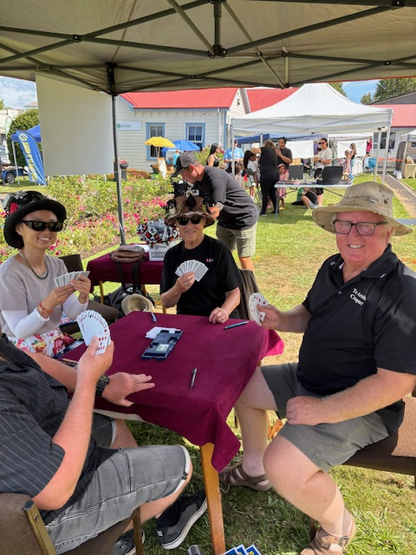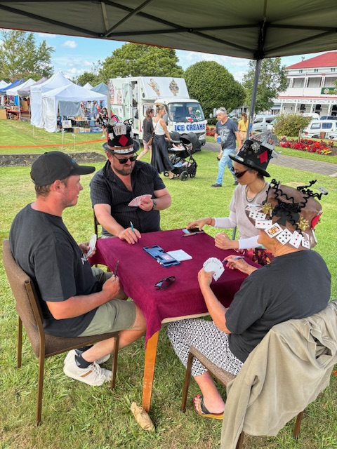
Dig those hats! Many who came past our stand did.

Thanks to all those who came along and played and demonstrated bridge and to Ross for the loan of his gazebo.
The day is not just about getting new members (though that is central to the display) but also to let those present at Domain Day know that bridge is a great game to play, a lovely way to spend a Tuesday night or Friday day in Te Aroha.
New Granddads … and New Babes, too!
I thought it was an appropriate time to have a “ new grandfather’s corner”. For this to happen, it is not just that the grandfathers are first-timers but the babies are too!
Three of club members recently joined the “New Grandfathers’ Club” and here they are celebrating with the newly borne…and in a couple of cases, the grandmothers as well.

I am sure the gent in the armchair needs no further introduction but in his arms is Nora Kate Allen. She has good bridge pedigree on her father’s side too with grandmother Annie and great granddad Kit both being players. On Nora’s mother’s side, there is a whole host of bridge players including her grandfather who lives in Te Aroha and plays quite a lot. Suitably confused?
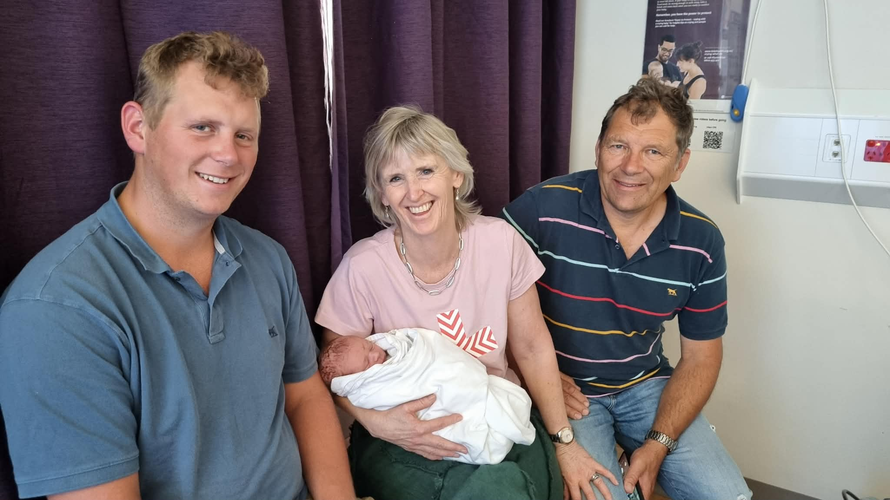
Samuel is the happy father. Then, we have Karen and Foster and Karen is holding George Foster Kalma.

We have Jordan Decker, Paul and Gaye’s son, who is looking after Theo Decker. Oops… what happened to the granddad?
Unlike Nora and George whose families live in or close to Te Aroha/ Auckland, Theo and his parents live in Canada.
Which One is Tim?

Now, many of you would think that the question above this photo is unnecessary. You all know that our Te Aroha Tim is on the right.
Absolutely correct.. but let me introduce you to the other two gentlemen. On the left, we have Tim Rigter and in the middle, we have Tim Rigter as well!
I had an interesting discussion at the recent Domain Day when the gentleman in the middle was introduced to me and tried to convince me his name was “Tim Rigter”. I had been standing in the sunshine for 4 hours trying to get those attending interested in our up-coming bridge lessons. Maybe I was seeing double as the other man talking to me (the one on the right in the picture) was also involved in our conversation.
Now, let’s get the records straight. It is a Rigter family tradition that the first- born male in any branch of the family is called Tim, or some variant…..and all three NZ cousins are thus called “Tim” and have the same surname. One lives in Te Aroha, one in Ashburton and the third in Dunedin.
Absolutely no problem until you meet two or maybe all three of them together. Then, confusion reigns. There is though a big advantage when it comes to remembering their first names and it is their issue not mine when they all answer when you address them as “Tim”.
I do believe only one of them is challenging for this year’s Te Aroha Slam Cup competition. Which one? Sorry, I am confused.
The photo was taken 11 years ago. That is why at least two of the Tims have more hair than at present.
Lessons at Te Aroha
Beginners’ Lessons started on 26th March at the club and here is a brief report from Charlotte on what happened:
“We had 7 keen, enthusiastic players turn up for the first bridge lesson of 2026. Unfortunately the rain put off a couple of potential learners. We are hoping to get a couple more next week. Well done to the club member who got a friend to come along. It would be great to have some club members pop in from time to time to help make up full tables and show the beginners how friendly our club is.”
A Happy Cam (per!)
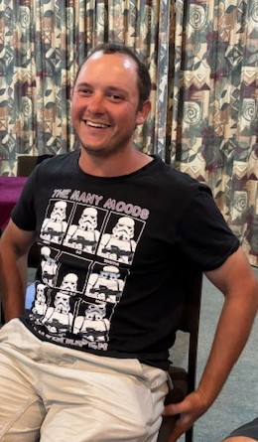
Why is Cam so happy after a recent Tuesday night bridge session? Well, could it be because, with a little help from his partner of the night, Alan Mace, that he scored 63.90 % and came first East-West? Well, of course, that is why. A great first night of the Jim Shine for Cam and Alan.
It’s a Green Night with Thames
The first night of our 2026 meetings with Thames players happens to coincide with St Patrick’s Day, a day when everyone regardless of nationality or the way they speak, becomes Irish for the day. There was plenty of Guiness drunk at “The Grand” dinner beforehand and available during play while “green” was certainly prominent in what everyone wore:
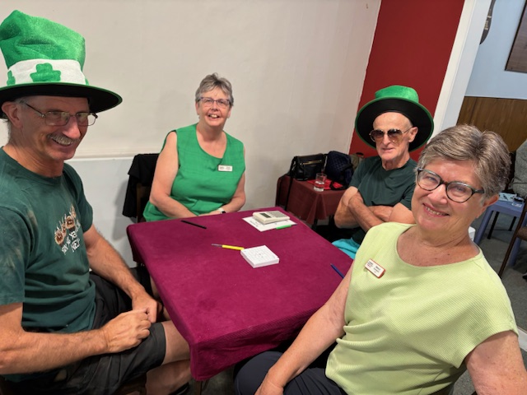
Was it the Guiness or was it that they played rather well (the latter, to be sure!) but Garry and Peter scored an excellent 60.04%, one of the best scores of the evening. Also pictured are Thames President, Karen Woodford, and Nancy Davenport. That’s pale green that Nancy was wearing.
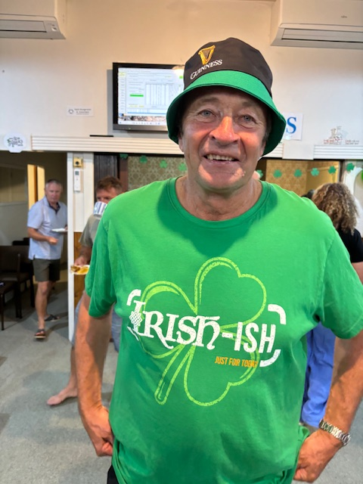 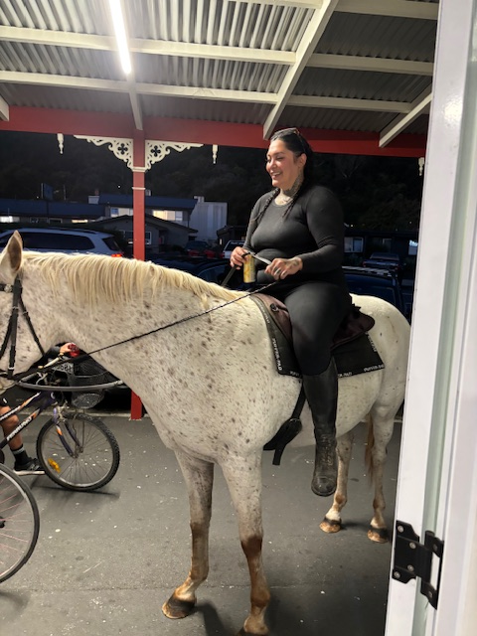
Now, you may recognize Tim O’Rigter (one of them!) but the other picture may need some explanation. The front door of the club was open to give some air and what is that we saw, a rider on horseback, the horse seemingly very interested in the bidding at table 6 as it peered through the door.
It is possible it noticed its fellow foal on the poster advertising bridge lessons and came down to sign up. Well, I said “possibly”! Horse and rider were the only ones not dressed in green that evening. Was that why they passed on by without coming in?
Tournament “Toppers”
Well, maybe not “toppers” though yours truly, with a little help from his Auckland partner, Jonathan Westoby, did lead the way at the Howick 5A earlier this month. However, Anna and Richard were rather pleased with their 4th place finish in the National Teams, in Christchurch, only a tiny distance off second. They were also 4th in the more recent Taranaki Congress 10A Teams.
Adri and Malcolm were slow starters in the Hamilton Intermediate Pairs but woke up after lunch to score 60.29% in the afternoon. They finished above half way in the 34 pair field. Cam and Damien were also slow out of the traps at the Cambridge Junior Pairs and also recovered after lunch with over 50% in the second session.
Looking Forward… to April
There’s my Improvers session on Wednesday April 22nd here at the club, mainly for Intermediate and keen Junior players… all welcome, though, as are players from other local clubs. 7.00pm until 10pm playing boards which have points of interest which hopefully will help you improve your game.
Assuming there is interest, there will be two further Wednesday sessions later in the year.
Cost is 5.00 per player per session. If you are coming, and you will need a partner, please give me a few days’ notice.
WAPS in Town
The second round of the Waikato Area Pairs will take place in our clubrooms on Sunday April 26th at 10am. It’s a 2- session event and it would be great to see a few of our club members take part, both Open and otherwise. There are prizes for best non-Open pairs.
Start time is 10am and the cost $15.00 per player, payable in cash on the day. If you are going to play, please enter in advance on the New Zealand Bridge website..or tell me and I will enter you.
Closer to the time, we will ask our club players to provide morning tea for this event.
As of 28th March, there are 16 pairs entered, which is great, but only Victor from our club, which is not so good. So come on, you Te Aroha players, have a nice day’s bridge ANZAC Weekend. I am sure the weather will be
 great for bridge!
Another Diary Date
Saturday June 6th. That’s when we all head off to the Silver Fern Farms Event Centre for the Spa Town Open Teams and the Spa Town Restricted Swiss Pairs. More about these events next month but it would be neat to see some of our Intermediate and Junior players taking part in the Swiss Pairs event…Open players, too.
Wisdom of Solomon

Up and Down Valuing
We know, hopefully, that when the opposition start with 1 of a suit, that to call 1NT we should have 15-17, maybe a poor 18 hcp and at least one hold in the opponent’s suit, a reasonably balanced hand, too.
High Card Point Count is not the only factor involved in decision making. Recently, Anna held this hand when her right-hand opponent opened 1D:

  East Deals
  Both Vul
  N
  W |  | E
  S
♠ | A J 10 9
♥ | 10 7
♦ | A Q 10 4
♣ | K 8 3

West | North | East | South
 |  | 1 ♦ | ?
Only 14 hcp but with an excellent diamond suit as well as good spade cards. Anna chose to bid 1NT, valuing her hand as 15 hcp. Had we been playing Teams, I would have bid 3NT on the rather poor North hand below but playing Pairs and was cautious only inviting. Thus, we played 2NT making 3NT when West chose to lead a spade (4 spades, 4 diamonds and CK).
East Deals  Both Vul
  ♠ | K 6 3
  ♥ | Q J 4
  ♦ | K 7 6 5
  ♣ | 9 6 5
  ♠ | Q 7 5 4
  ♥ | 9 8 3 2
  ♦ | 3
  ♣ | 10 7 4 2
  N
  W |  | E
  S
  ♠ | 8 2
  ♥ | A K 6 5
  ♦ | J 9 8 2
  ♣ | A Q J
♠ | A J 10 9
♥ | 10 7
♦ | A Q 10 4
♣ | K 8 3

West | North | East | South
 |  | 1 ♦ | 1 NT
Pass | 2 ♠ | Pass | 2 NT
All pass
On the same evening, I held the North hand below:
West Deals  Both Vul
  ♠ | A Q 7 4 2
  ♥ | J 3
  ♦ | 8 6 5 4 2
  ♣ | A
  ♠ | K J
  ♥ | 8 6 5 4 2
  ♦ | K
  ♣ | Q 6 5 3 2
  N
  W |  | E
  S
  ♠ | 10 9 6 3
  ♥ | A 7
  ♦ | J 10 3
  ♣ | K 10 7 4
♠ | 8 5
♥ | K Q 10 9
♦ | A Q 9 7
♣ | J 9 8

West | North | East | South
Pass | 2 ♠ | Pass | 3 ♣
Pass | 3 ♦ | All pass
I could have opened 1S with 11 hcp but the diamond suit was really poor and I decided to value my hand down and opened 2S, showing 5 spades and a 5 card minor with 6-10 hcp. We played quietly in 3D making 10 tricks while others failed in 5D. 5D is a lucky make requiring one to drop the singleton king under the ace and then take a successful spade finesse. No-one made 5D. So, some hands we value up and some we value down, all part of doing better at bridge, we hope!
More from me in April. Richard

